MULTILINGUAL STORY GENERATION AND SPEECH SYSTEM
Design and Implementation
Department of Computer Science and Engineering, TKR College of Engineering & Technology
Batch C2 (CSE-C) · Academic year [ACADEMIC YEAR]
Table 1: Project team
S.No. | Student name | Roll number
1 | Lingala Sindhu | 23K91A05D3
2 | Padige Ajay | 23K91A05H8
3 | Mahek Ansari | 23K91A05D8
4 | Maheshwaram Hari Krishna | 23K91A05D9

Project guide: A Tejaswini
Chapter and section numbers quoted in the text (for example Chapter 8 or Section 6.2) refer to the full project report, 17.Final Document. Figures and tables in this document are numbered from 1.

1. DESIGN
This chapter describes how StoryVox is put together: the architecture and workflow, the data flow, the UML and data design, the modules, the API and the user interface. The diagrams were drawn from the code in app/; the complete set, each with a longer explanation, is also in the Block Diagrams document. A note on scope: the product is a single-user local application. It has no accounts, no queue and no scheduler, and these absences are design choices that the sections below explain rather than hide.

1.1 Design goals and architecture
Five goals shaped the design. First, local first: after the one-time model download nothing leaves the machine, and every story and narration is stored in a SQLite file and a folder of WAV files. Second, truthful provenance: every story row and every audio row records the identifier of the model that produced it, so a fallback can never pass as the neural model. Third, never serve silence: the narration service rejects empty or silent audio and moves to the next provider; if all fail the request returns an error and the story is kept without audio. Fourth, honest evaluation: every number on the Evaluation page is computed at run time from real outputs, and a number that cannot be computed is shown as a dash. Fifth, thin routes: the routes validate input and map errors, and the work lives in four service modules, so the same functions serve the web application, the test suite and the experiment scripts.
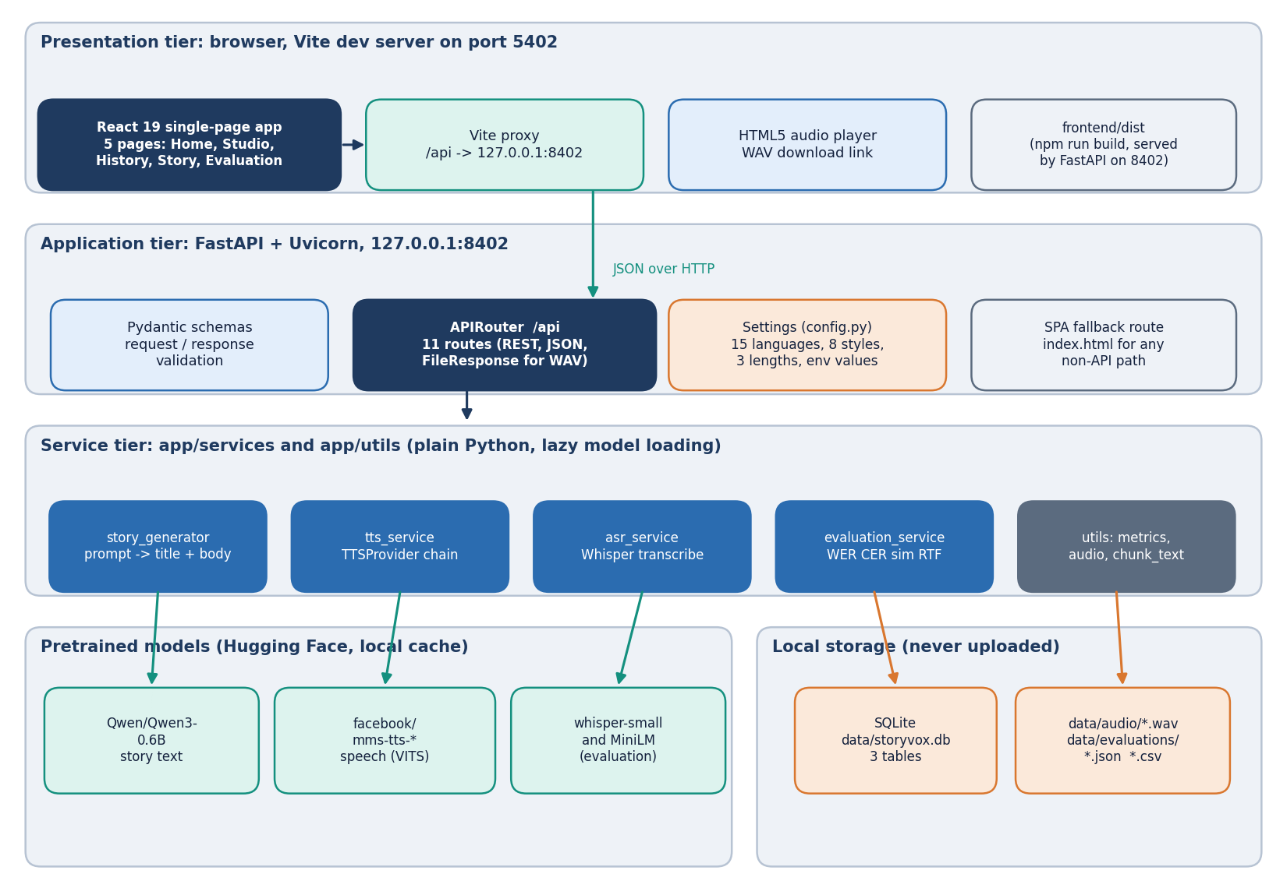
Figure 1: Layered architecture of StoryVox: React console, FastAPI application with 11 API routes, the service layer, pretrained models, SQLite and WAV storage.
In development the React application is served by Vite on port 5402 and the Vite proxy forwards every /api request to the FastAPI application on 127.0.0.1:8402; in production npm run build writes frontend/dist, and the same FastAPI process serves the built files, with a fallback route that returns index.html for any path that is not an API route or an asset, so the browser always sees one origin. For that reason the application defines no cross-origin rules. The application has one router with 11 routes. Settings come from environment variables (read on every instantiation so that tests can isolate them), the models are loaded lazily on first use under a lock and cached in module variables, and a request that arrives while a model is loading simply waits for the lock.
The deliberate gaps in this architecture are worth stating. There is no authentication because the tool runs on one machine for one person, and the server is bound to 127.0.0.1. There is no job queue: a generation request runs inside the request, so the browser waits (about 22 s for a Short story on this CPU), and a second request waits for the same processor. SQLite is opened with check_same_thread=False and every request uses its own session, which is adequate for one user and was not tested under concurrent load. The configuration also defines MAX_AUDIO_UPLOAD_MB and a dataset folder that no route uses; they are leftovers from the reference-audio objective that was not built.

1.2 High-level workflow
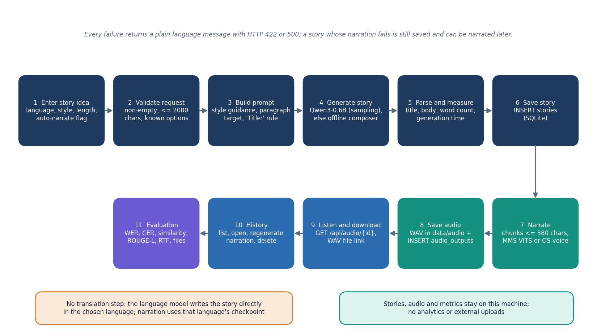
Figure 2: End-to-end workflow: enter an idea, validate, build the prompt, generate, parse, save, narrate, store the audio, play, manage history and evaluate.
The workflow has seven stages. Validate: the route rejects an empty or over-long idea and an unknown language, style or length. Prompt: the service builds one instruction that names the style, the language, the paragraph target (3, 5 or 8) and the rule that the first line must start with Title:. Generate: the language model samples at temperature 0.8 and top-p 0.9 up to 220, 420 or 700 new tokens; if it cannot be loaded or returns fewer than 20 words, the offline composer writes the story. Save: the title, body, word count and generation time become a stories row. Narrate: the text is cut into chunks of at most 380 characters at sentence ends, every chunk is synthesised, normalised to a peak of 0.9 and joined with 0.25 s pauses, and the WAV file and an audio_outputs row are written. Play and manage: the browser plays and downloads the audio; History lists, opens, re-narrates and deletes. Evaluate: the Evaluation page runs the loop of Section 5.6.
Two properties of this workflow matter for the results in Chapter 8. There is no translation step: the language is a word in the prompt and nothing checks that the output is in that language. And narration depends only on the language code, not on the language of the text, so a story that came out in English is read by the checkpoint of whatever language was requested.

1.3 Data flow diagrams

1.3.1 Level 0: context
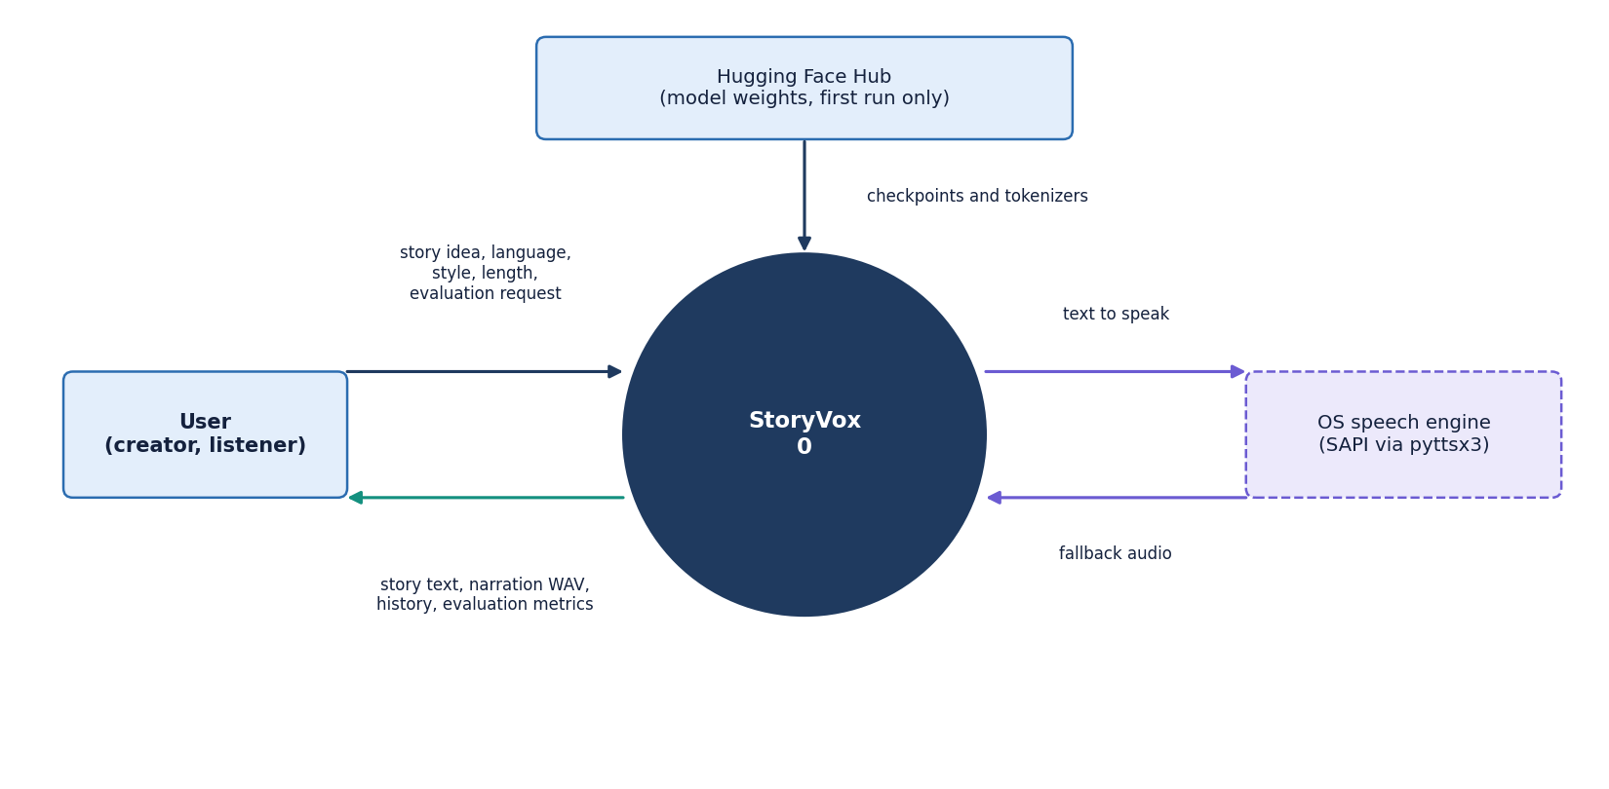
Figure 3: Context diagram (DFD level 0): StoryVox as one process with the user, the Hugging Face Hub and the operating-system speech engine.
At level 0 StoryVox is one process with three external entities. The user supplies story ideas, choices and evaluation requests and receives stories, audio, the story list and metrics. The Hugging Face hub is the source of model weights and tokenizers; it is contacted only when a model is not yet in the local cache. The operating-system speech engine receives text and returns audio only when the neural checkpoint cannot be used. No analytics service and no cloud storage appear because the product does not use them.

1.3.2 Level 1: five processes
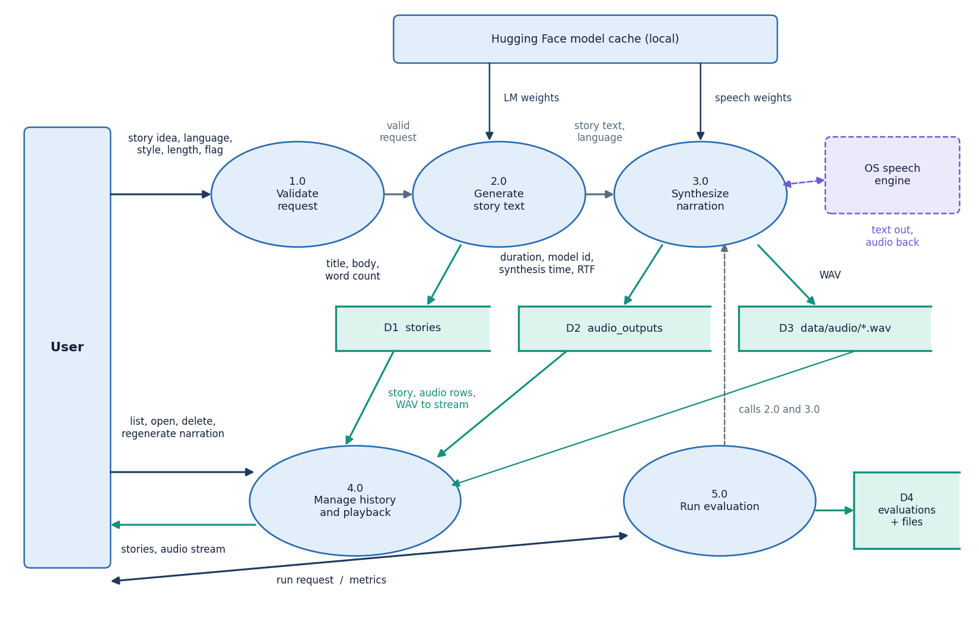
Figure 4: DFD level 1: five processes (validate, generate story, synthesise narration, manage history, run evaluation) and the data stores D1 to D4.
Level 1 shows the five processes and four data stores. 1.0 Validate checks the request. 2.0 Generate story writes the title, body and word count to D1 (stories). 3.0 Synthesise narration writes the WAV file to D3 (audio folder) and the duration, model id, synthesis time and real-time factor to D2 (audio_outputs). 4.0 Manage history reads D1, D2 and D3 to list, open, stream and delete stories and to regenerate narration. 5.0 Run evaluation calls processes 2.0 and 3.0 on built-in prompts, transcribes the audio and writes the metrics to D4 (one evaluations row plus a JSON and a CSV file).

1.3.3 Level 2: narration
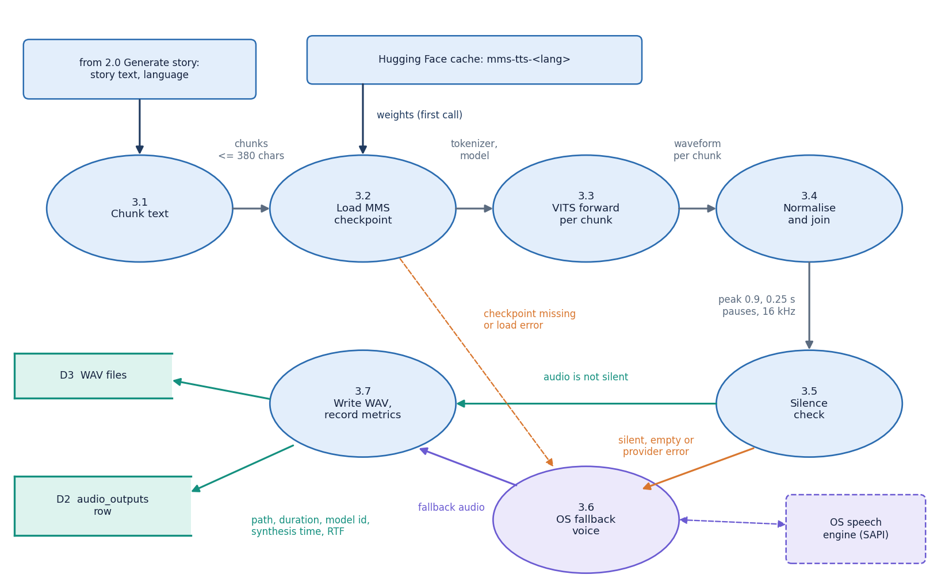
Figure 5: DFD level 2: process 3.0 expanded into seven sub-processes, from chunking to the written WAV file, including the silence check and the fallback voice.
Narration is expanded to level 2 because it is where the product can fail and where most of the measured time goes. Seven sub-processes take the story text to a stored WAV file: chunking, loading the checkpoint once and caching it, running the VITS model on each chunk, normalising and joining, rejecting empty or silent audio, the operating-system fallback, and computing the duration and real-time factor. A silent result, an empty result or any load or inference error sends the text to the fallback; the fallback's result is resampled to 16 kHz so that the rest of the system sees one format.

1.4 UML design

1.4.1 Class diagram
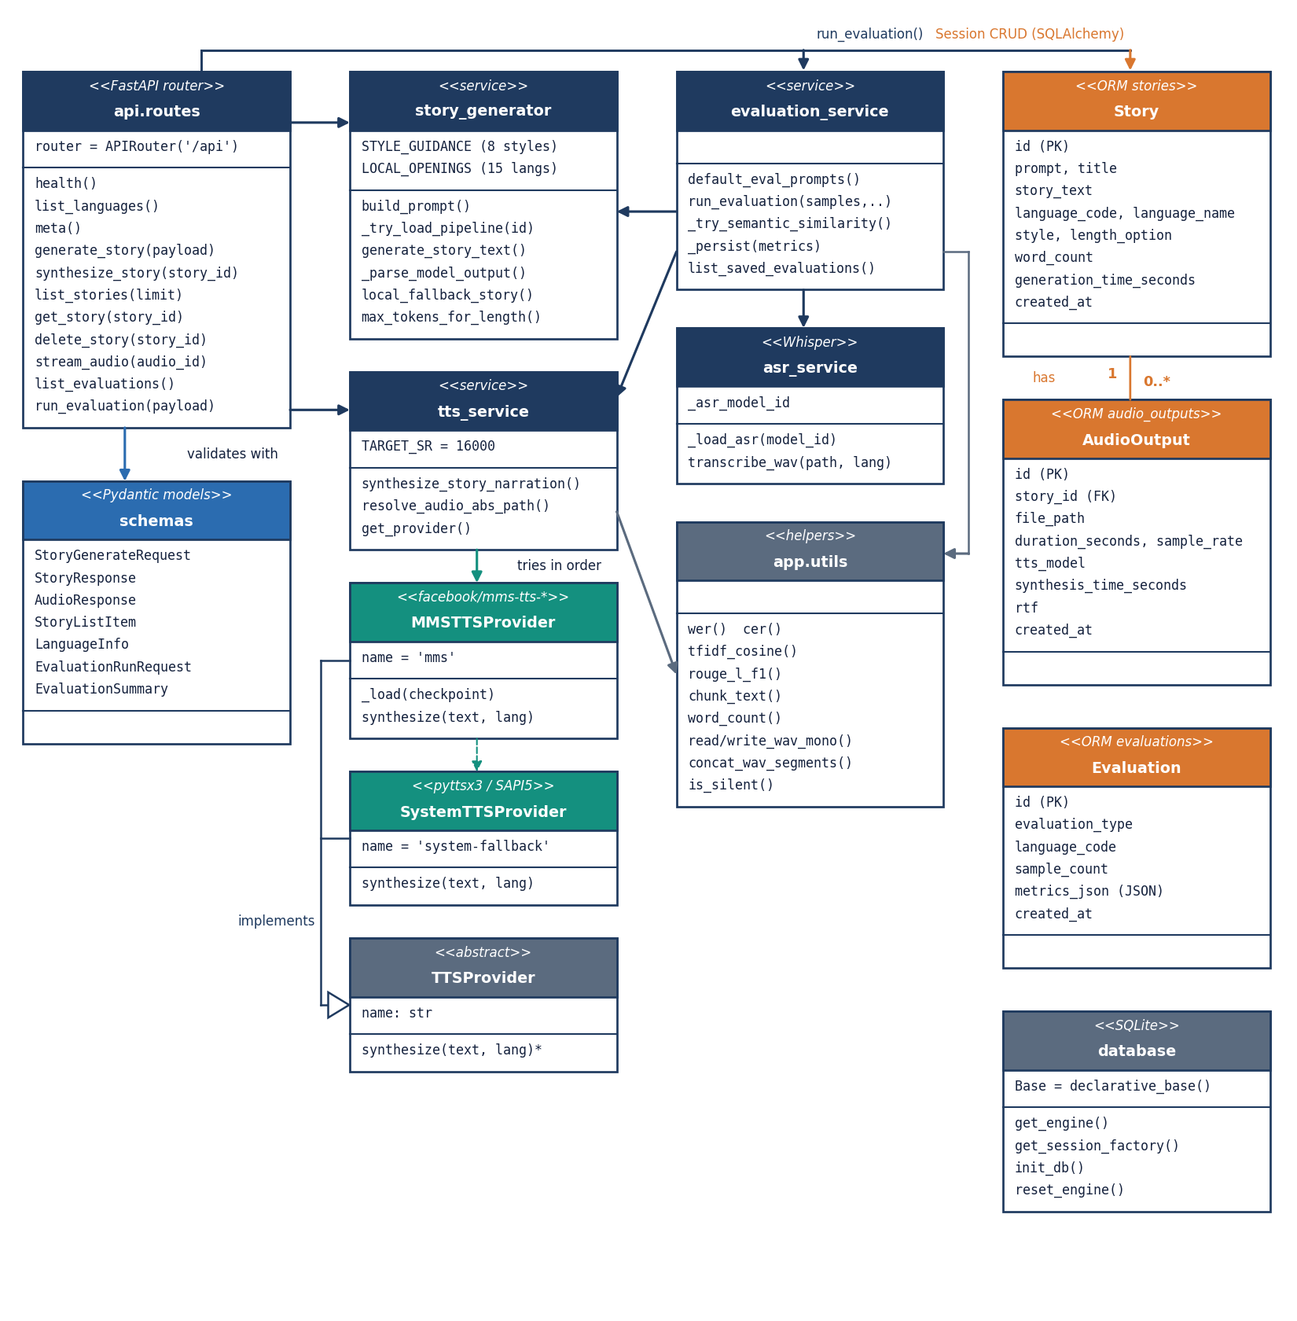
Figure 6: UML class diagram: API routes and schemas, the story and speech services with the TTSProvider hierarchy, evaluation and helper modules, and the three ORM classes.
Most of the code base is modules of functions, which suits a pipeline in which each step takes text or audio and returns text or audio; the diagram draws each module as a class-like box. The real classes are the abstract TTSProvider with its two implementations MMSTTSProvider and SystemTTSProvider, the Pydantic schemas of the API, and the three ORM classes. Story owns zero or more AudioOutput objects through a cascading relationship; Evaluation stands alone and keeps its metrics in one JSON column.
Table 2: Principal modules and the data they pass on.
Module | Takes | Returns
story_generator | Idea, language code, style, length | Title, body, model id, elapsed seconds
tts_service | Story text, language code | Relative WAV path, duration, sample rate, model id, synthesis time, RTF
asr_service | WAV path, language code | Transcript text
evaluation_service | Sample count, optional language, skip flags | Metrics dictionary with averages and per-sample rows; JSON and CSV files
utils.metrics | Reference and hypothesis text | WER, CER, TF-IDF cosine, ROUGE-L
utils.audio | Waveform arrays, WAV paths | Joined audio, resampled audio, silence decision

1.4.2 Sequence diagram
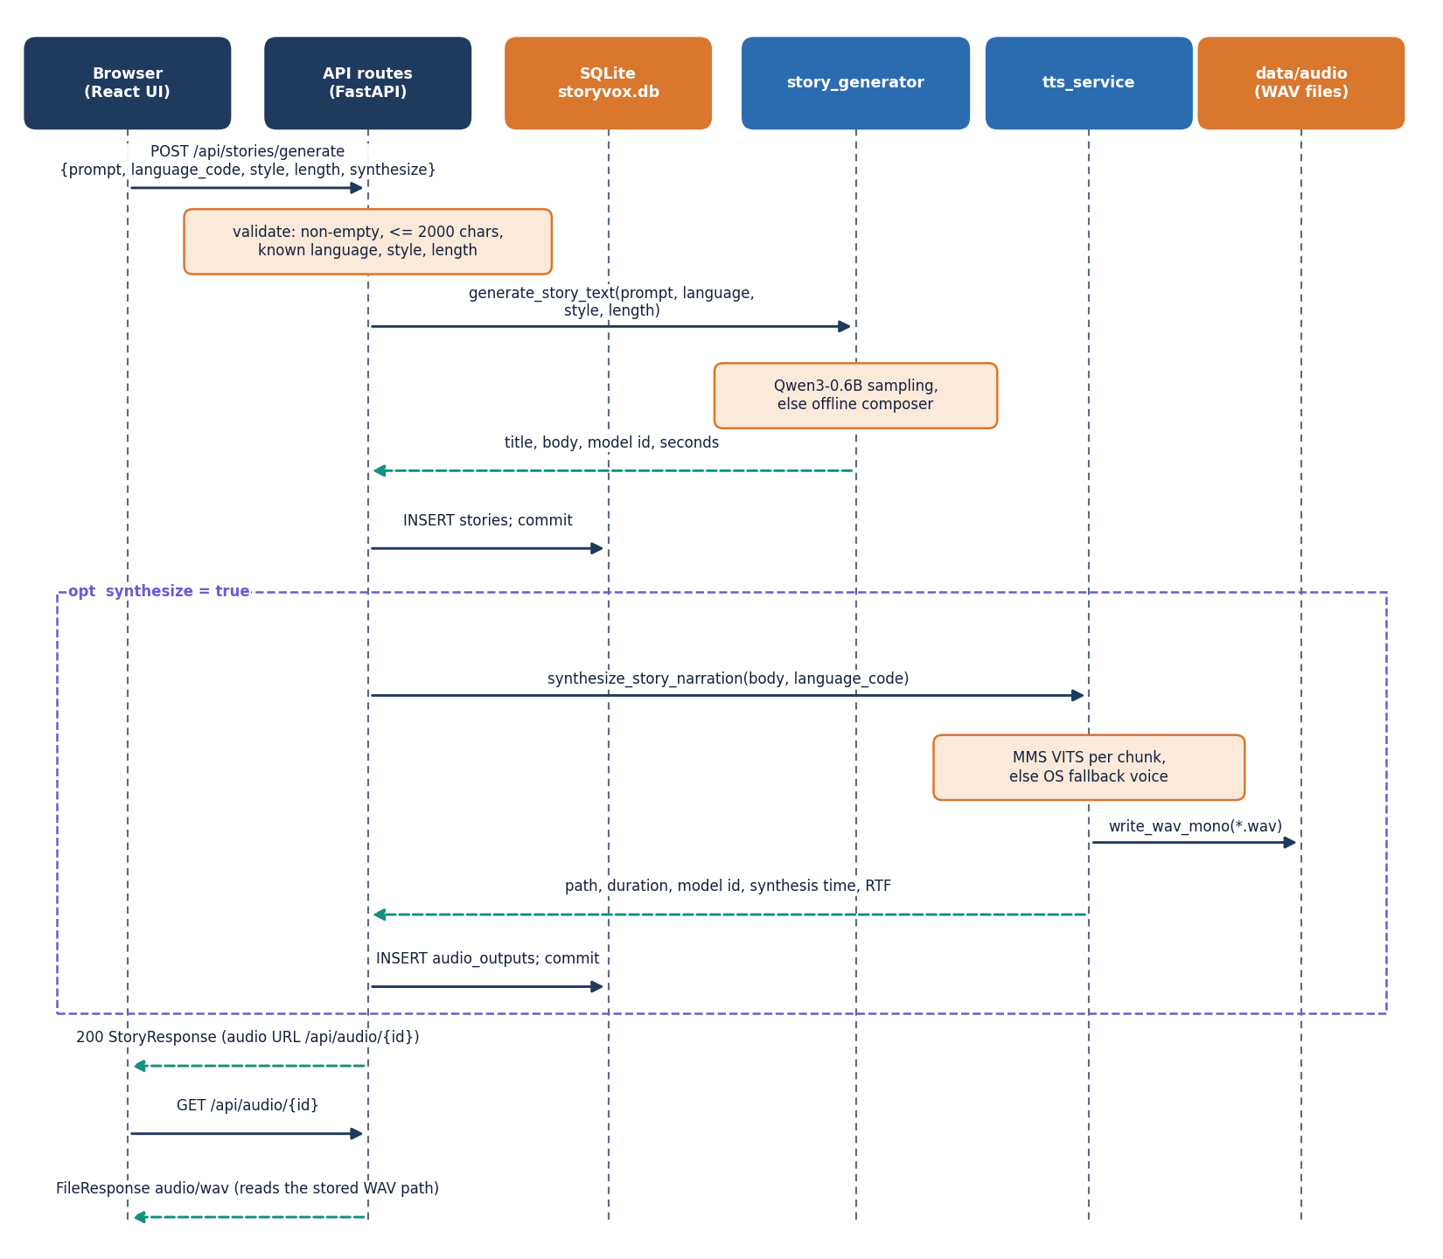
Figure 7: Sequence diagram of POST /api/stories/generate with narration, followed by the audio request.
The sequence follows POST /api/stories/generate with narration. The route validates the request, calls generate_story_text, inserts the stories row and then, if synthesize is true, calls synthesize_story_narration and inserts the audio_outputs row. If narration raises an error the story is still saved and returned without audio so that it can be narrated later through POST /api/stories/{id}/synthesize. The measured end-to-end time of this call for a Short story was 36.8 s in the length experiment, of which 22.1 s was generation, and the browser then fetches the audio with GET /api/audio/{id}.

1.4.3 Use-case diagram
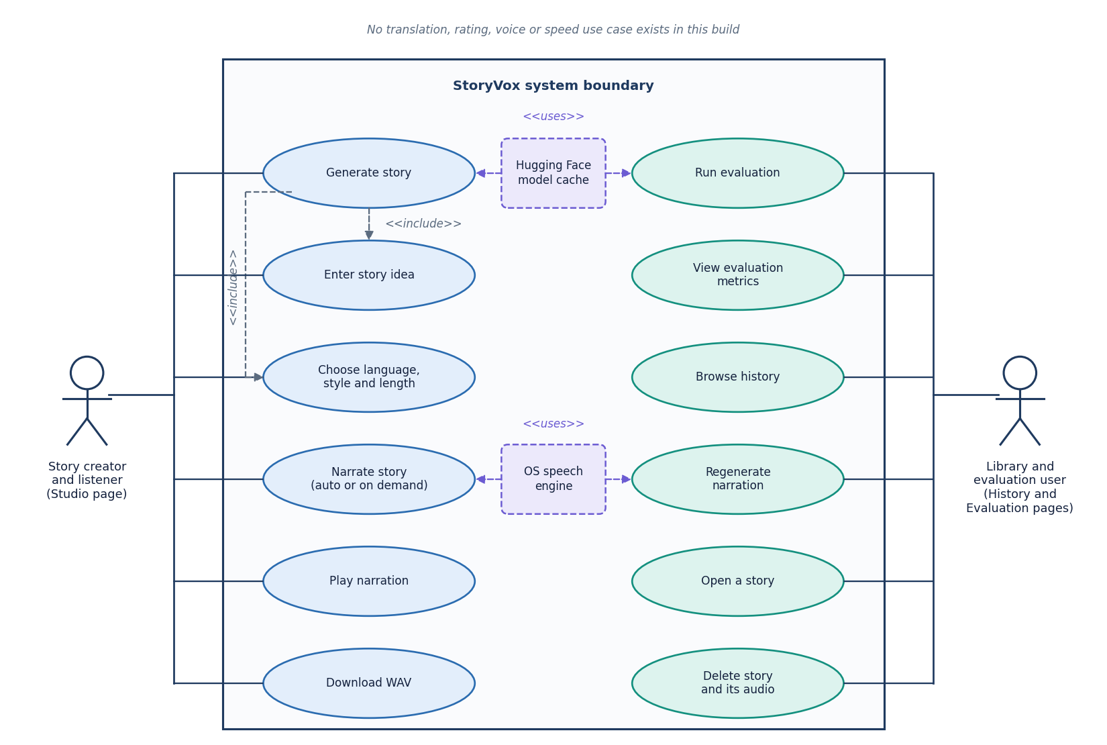
Figure 8: Use-case diagram: the story creator and the library and evaluation user, twelve use cases, and the model cache and speech engine as supporting systems.
The product has no accounts, so the two actors are roles of the same local user. The story creator works in the Studio: enters an idea, chooses language, style and length, generates, narrates, plays and downloads. The library and evaluation user works on History, Story and Evaluation: browses, opens, regenerates narration, deletes, runs an evaluation and reads the metrics. The model cache and the operating-system speech engine are supporting systems. Translation, rating, voice choice, speed control and reference-audio upload are not use cases of this build.

1.5 Database design
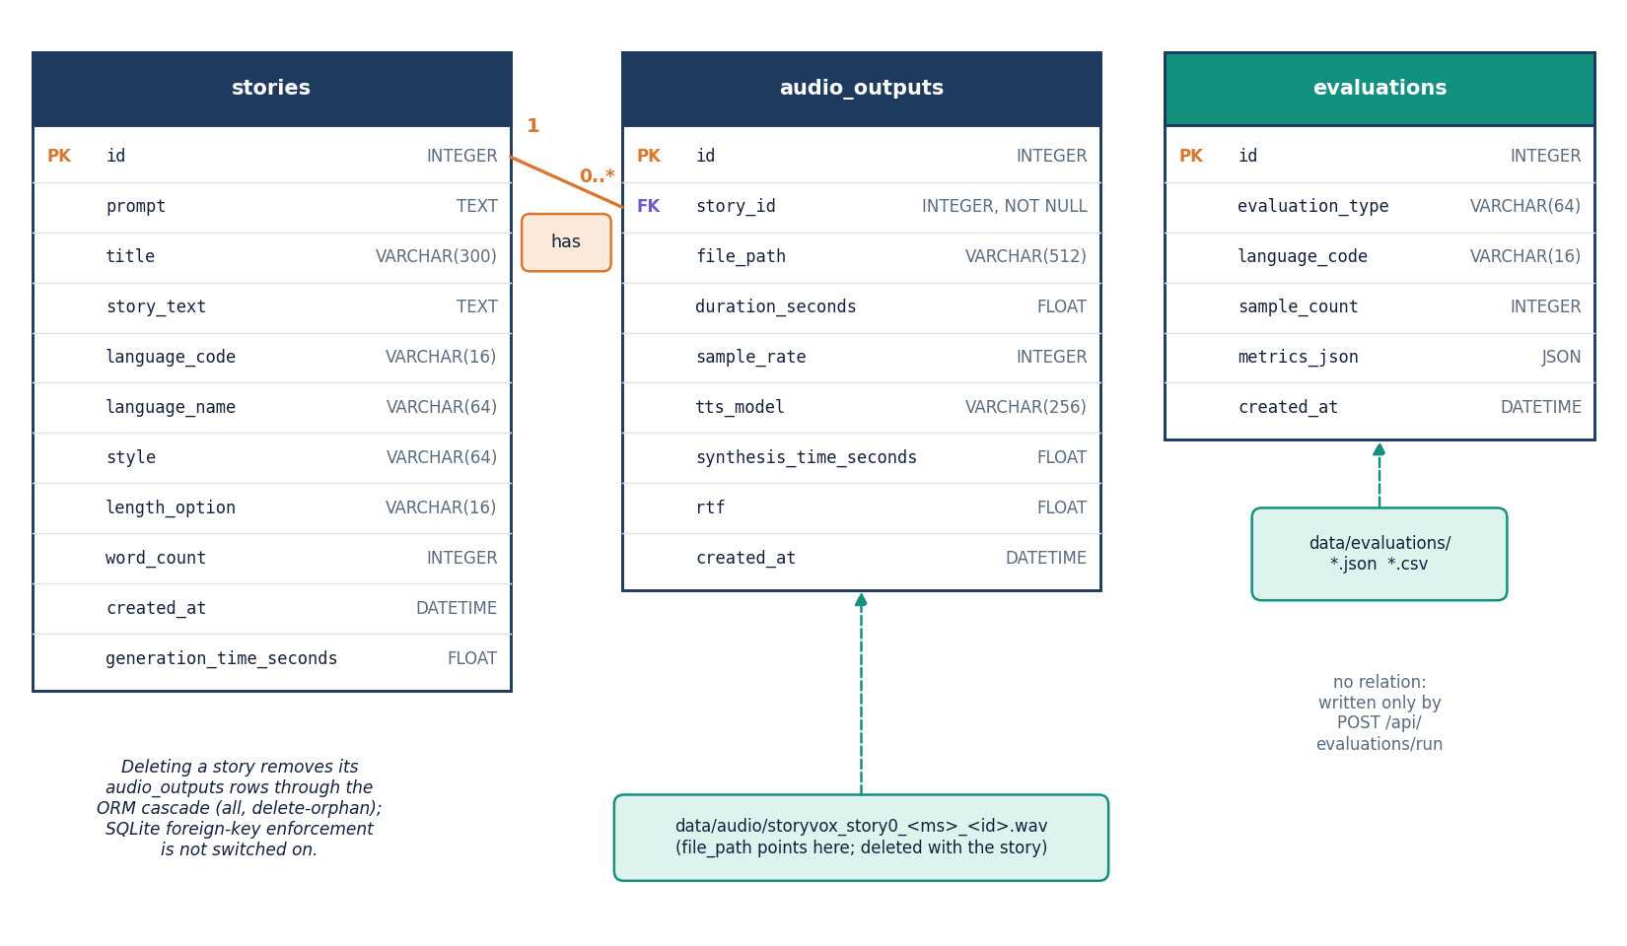
Figure 9: Entity-relationship diagram of the SQLite database: stories (1) to audio_outputs (0..*), and the stand-alone evaluations table.
The database data/storyvox.db has three tables created by SQLAlchemy at start-up. The tables and their columns are listed below. A story can have several narrations because regenerating narration adds a row instead of replacing one.
Table 3: Tables of the SQLite database.
Table | Columns | Notes
stories | id, prompt, title (300), story_text, language_code, language_name, style, length_option, word_count, created_at, generation_time_seconds | One row per generated story; title and body are stored as the parser produced them
audio_outputs | id, story_id (foreign key), file_path, duration_seconds, sample_rate, tts_model, synthesis_time_seconds, rtf, created_at | One row per narration; tts_model is the speech checkpoint or system-tts-offline-fallback
evaluations | id, evaluation_type, language_code, sample_count, metrics_json (JSON), created_at | Stand-alone; the same payload is written to data/evaluations as JSON and CSV

The foreign key is declared with ON DELETE CASCADE and the ORM relationship cascades deletes, but SQLite does not enforce foreign keys unless the pragma is switched on, and the application does not switch it on; deleting a story therefore removes its audio rows through the ORM, not through the database, and the delete route also removes the WAV files. Three folders persist across restarts: data/audio (WAV files), data/evaluations (JSON and CSV) and data/datasets (created at start-up and not used by any route). The .gitignore excludes the database, the audio and the evaluation files.

1.6 Core algorithm design
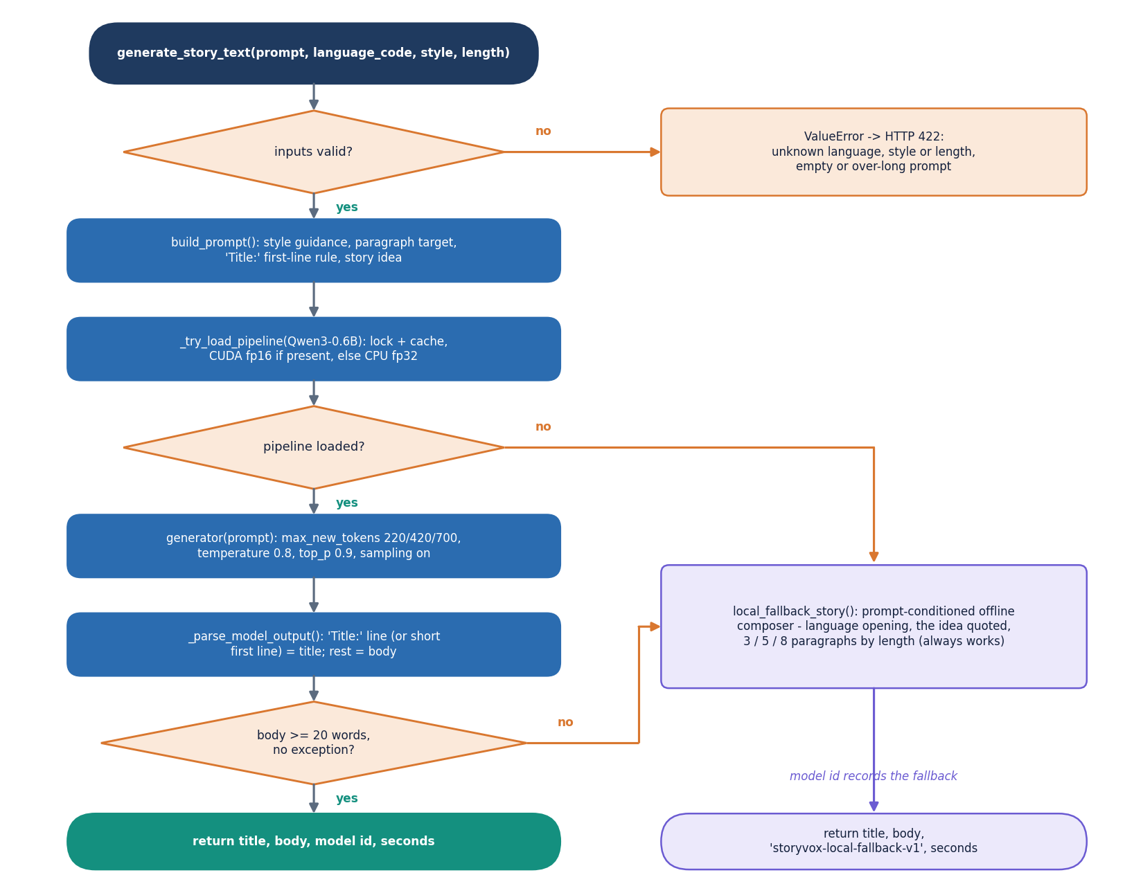
Figure 10: Flowchart of generate_story_text: validate, build the prompt, load the model once, sample, parse, check the length and otherwise use the offline composer.
The story algorithm is a short chain with two guards. Input guards reject an unknown language, style or length, an empty idea and an idea over 2,000 characters before any model runs. The output guard is the 20-word rule: a body shorter than 20 words, or any exception in the pipeline, switches to the offline composer, which always returns a story that quotes the idea, and the model id returned to the caller says which path produced the text. The parser takes a Title: line (or a short first line) as the title and the rest as the body; when neither exists the title is Untitled Story. A consequence, measured in Chapter 8, is that the guard checks length only, not language, not instruction echo and not narrative quality.
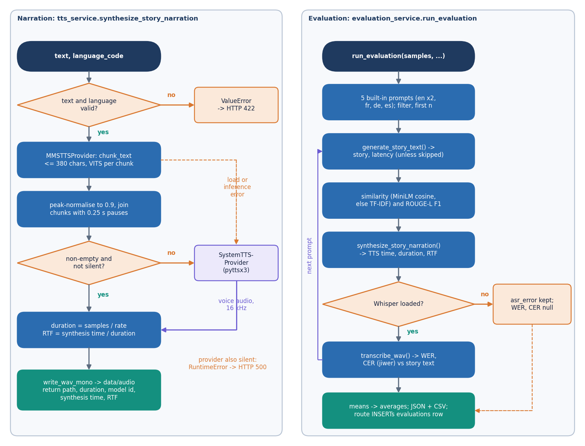
Figure 11: Left: the narration provider chain with its silence check and fallback. Right: the evaluation loop that produces WER, CER, similarity, ROUGE-L and RTF.
On the left of the second flowchart, narration tries the neural provider first and the operating-system provider second, and applies the silence test to whatever comes back; the real-time factor is synthesis time divided by audio duration. On the right, the evaluation takes the first n of five built-in prompts (English adventure, English bedtime, French fantasy, German inspirational, Spanish mystery), generates and narrates a story for each, computes the prompt-story similarity and ROUGE-L, transcribes the audio with Whisper and computes WER and CER against the story text. If the recogniser raises an error the message is stored in the row and WER and CER stay empty, which is exactly what happened for story-length audio in this project (Chapter 8).
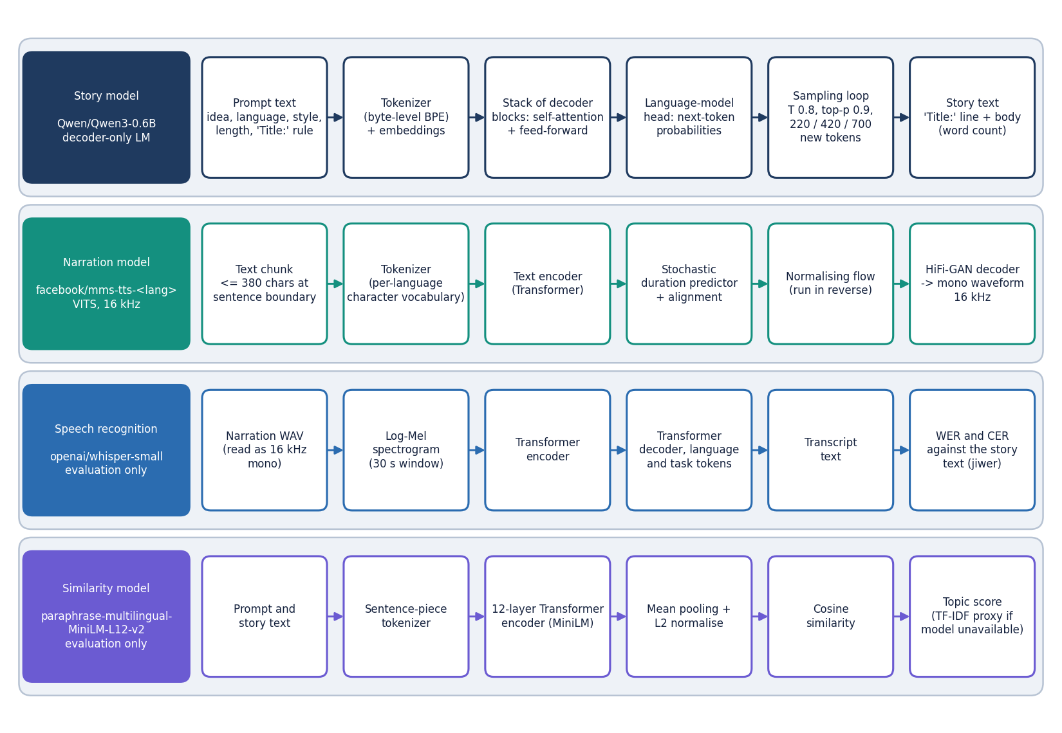
Figure 12: The four pretrained models used by StoryVox, each shown as its processing chain: Qwen3-0.6B, MMS-TTS (VITS), Whisper-small and multilingual MiniLM.
StoryVox trains no model. The Qwen3-0.6B decoder continues the prompt token by token; each MMS checkpoint is a VITS model whose text encoder, duration predictor and flow produce a latent representation that a HiFi-GAN decoder turns into a 16 kHz waveform [9], [10]; Whisper-small and the multilingual MiniLM encoder are used only by the evaluation [11], [14]. Supporting a language means mapping its code to a checkpoint in app/config.py, which is also where the three non-existent checkpoints (Italian, Chinese, Japanese) are named.

1.7 Module design
The code is split so that each file has one reason to change. Line counts below were measured from the repository.
Table 4: Modules, sizes and responsibilities.
Module | Lines | Responsibility
app/main.py | 48 | Creates the FastAPI application, mounts the built web application and the single-page-app fallback route
app/config.py | 110 | Settings read from the environment; the 15 languages with their checkpoints, 8 styles and 3 lengths
app/database.py | 47 | SQLite engine, session factory, table creation and creation of the data folders
app/models/__init__.py | 60 | ORM classes Story, AudioOutput and Evaluation
app/schemas.py | 81 | Pydantic request and response models (generate request, story, audio, evaluation run)
app/api/routes.py | 254 | The 11 REST routes, validation and error mapping
app/services/story_generator.py | 185 | Prompt builder, lazily loaded Qwen3 pipeline, output parser, offline composer
app/services/tts_service.py | 180 | TTSProvider interface, MMS and operating-system providers, WAV writing
app/services/asr_service.py | 42 | Lazily loaded Whisper pipeline for the evaluation
app/services/evaluation_service.py | 174 | Built-in prompts, the measurement loop, JSON and CSV output
app/utils/__init__.py | 76 | Word count, reading time, sentence chunking, file-name helpers, directory guard
app/utils/audio.py | 71 | WAV read, write, resample, join with pauses, RMS and silence test
app/utils/metrics.py | 73 | WER, CER, TF-IDF cosine and ROUGE-L
frontend/src/ | 3,253 | React 19 application: 5 pages, in-house UI kit, charts, API client, theme and motion helpers
tests/ | 340 | 29 pytest tests (8 API tests, 21 unit and edge-case tests)
scripts/ | - | Experiment, measurement and screenshot scripts; the smoke test, the data download and the evaluation command line

Three decisions about this structure are worth recording. The routes do not contain pipeline logic: routes.py validates, calls a service and maps exceptions to status codes. The experiment scripts import the same app.services functions as the API, so the numbers in Chapter 8 come from the product's code and not from a parallel implementation. And the web application has its own small UI kit (buttons, cards, tables, tabs, toasts, charts), so the pages contain layout and calls and no styling.

1.8 API design
All routes live under /api. Reads are GET and actions are POST or DELETE. Failures return the FastAPI detail string, which the web application shows verbatim, so messages are written for the user: 'Please enter a story idea.' is what a 422 says. The status codes follow one rule: 422 means the request was understood but a value is not acceptable, 404 means a story, an audio record or a file is missing, and 500 means a model or the speech engine failed; the detail never contains a stack trace, which goes to the server log.
Table 5: The 11 routes of the StoryVox API (plus the single-page-app fallback).
Method | Path | Purpose | Errors
GET | /api/health | Liveness check: status, application name, whether CUDA is available, server time | -
GET | /api/languages | The 15 supported languages with their speech checkpoints | -
GET | /api/meta | Styles, lengths, story model name and recogniser model name | -
POST | /api/stories/generate | Validate, generate a story, save it and (if asked) narrate it; returns the story with its audio record | 422 empty, over-long, unknown language, style or length; 500 model failure
POST | /api/stories/{id}/synthesize | Narrate a saved story again and add an audio record | 404 unknown story; 422; 500 narration failure
GET | /api/stories | Stories, newest first, with an audio flag; limit 1 to 200 (default 50) | 422 limit out of range
GET | /api/stories/{id} | One story with reading time, listening time and the latest audio | 404
DELETE | /api/stories/{id} | Delete the story, its audio rows and the WAV files inside the audio folder | 404
GET | /api/audio/{id} | Stream the stored WAV file as audio/wav with a download file name | 404 record or file missing; 400 invalid stored path
GET | /api/evaluations | Saved evaluation runs (50 newest rows; if the table is empty, up to 20 JSON files on disk) | -
POST | /api/evaluations/run | Run the measurement loop (samples 1 to 30, optional language, skip narration, skip story) and save the result | 422 unknown language; 500 failure

POST /api/stories/generate is the main route. Its body has the idea, the language code, the style, the length option and a synthesize flag (default true). The response is a StoryResponse with the story, its word count, reading and listening time, the generation time and, when narration ran, an audio object whose file_path is the URL /api/audio/{id}. Interactive documentation is generated by FastAPI at /docs.

1.9 User interface design
The web application has five pages: a public Home page, the Studio, History, a Story page and Evaluation, plus a not-found page. Pages are loaded lazily so that the Home page does not pay for the charts. The visual language is a flat, high-contrast grid with thick borders, one accent colour and monospace labels; a light and a dark theme are available from every page, and the choice is kept in browser storage guarded by try and catch.
Table 6: Application pages and the endpoints they use.
Page | Route | Endpoints used
Home | / | None (public page)
Studio | /studio | GET /api/languages, /api/meta; POST /api/stories/generate; GET /api/stories/{id} (to restore ?story=)
History | /stories | GET /api/stories?limit=100, /api/audio/{id}; DELETE /api/stories/{id}; the shell reads /api/languages, /api/meta, /api/health once
Story | /stories/:id | GET /api/stories/{id}, /api/audio/{id}; POST /api/stories/{id}/synthesize
Evaluation | /evaluation | GET /api/evaluations; POST /api/evaluations/run

Four design rules were applied to every working page. Each page opens with its purpose. Long actions show a busy state with an elapsed-time counter and finish with a notice. Numbers that are missing are shown as a dash with the reason ('Needs narration + transcription'), never as zero. Errors from the API are shown in a panel with a retry button, and deleting asks for confirmation and says that the audio will be removed too. Chapter 8 shows every page with real data; the three screens below illustrate the design itself.
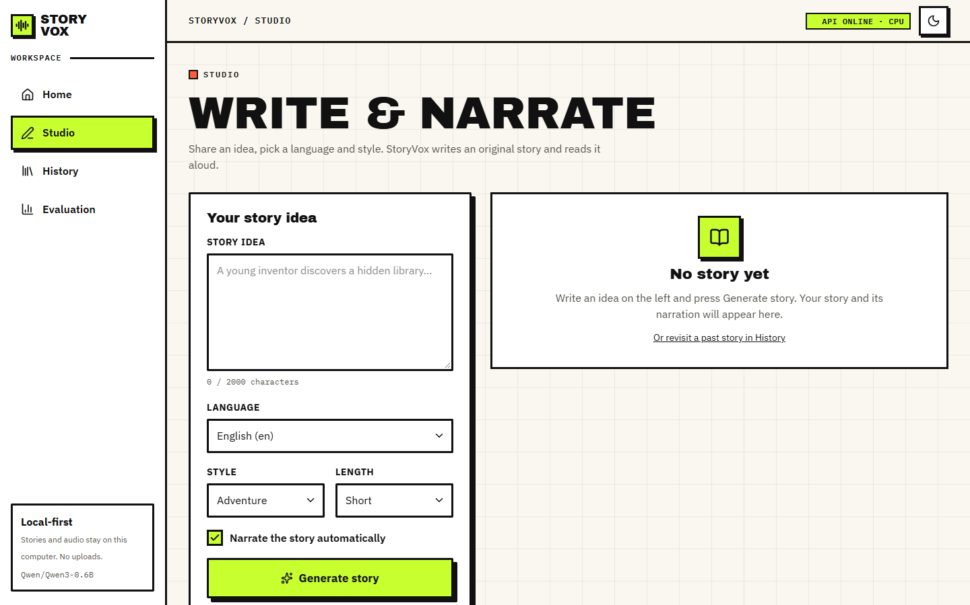
Figure 13: Studio before generating: idea box with character counter, language, style and length selectors and the automatic-narration option.
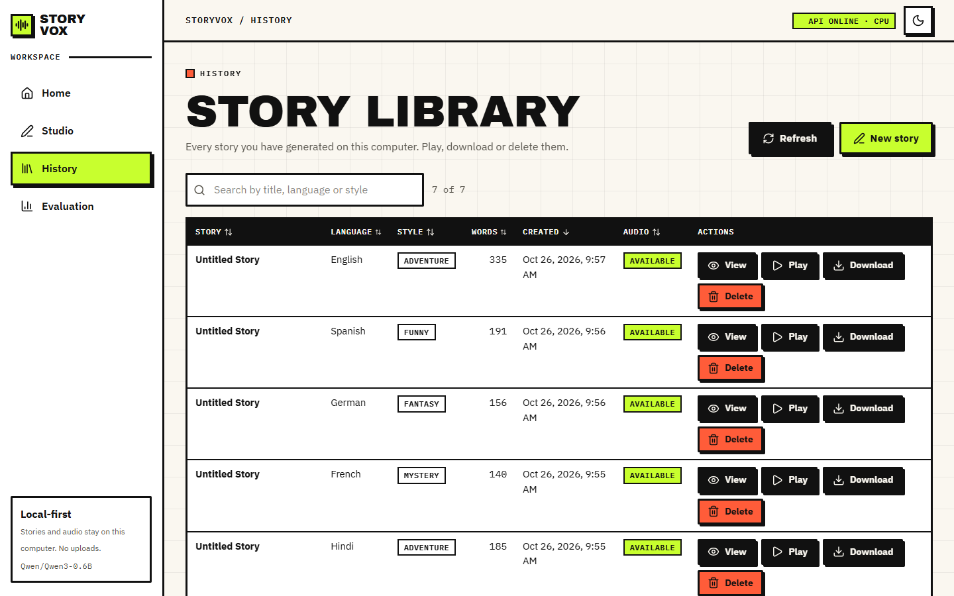
Figure 14: History page: searchable, sortable story library with play, download and delete actions.
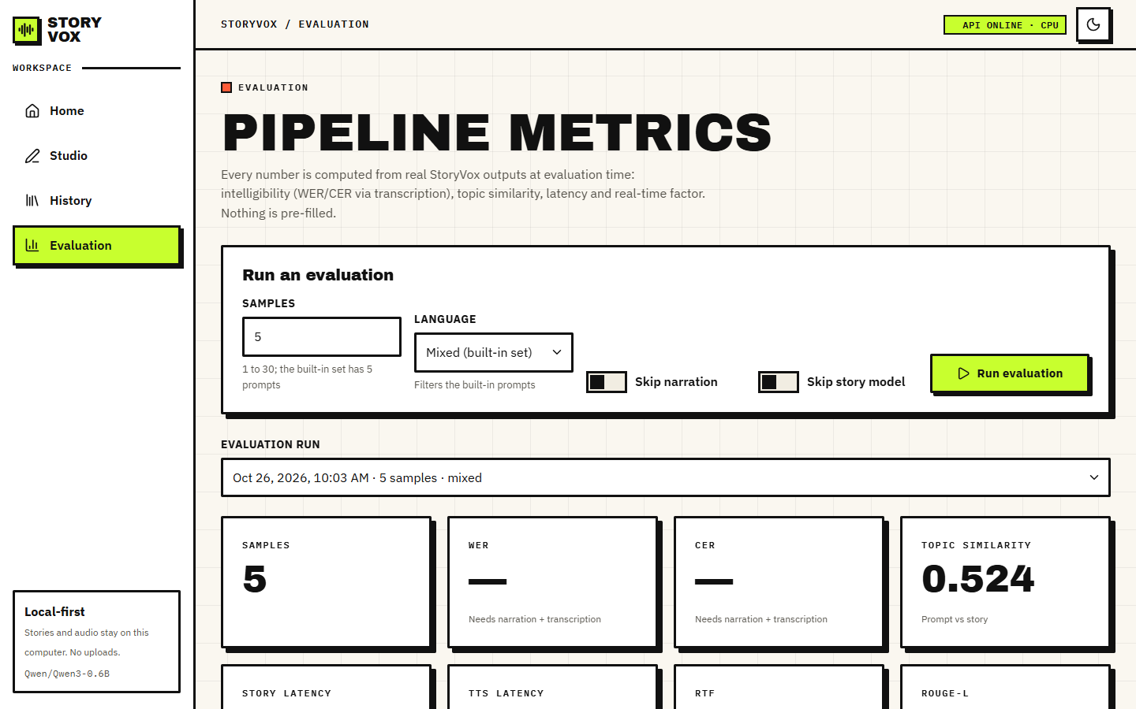
Figure 15: Evaluation page: run form, run selector and metric cards; WER and CER show a dash because the recogniser could not process story-length audio.

1.10 Design decisions and trade-offs
Every design has costs. The table records the main decisions, what each bought and what it cost, so that the limitations in Chapter 9 can be traced back to a choice and not to an accident.
Table 7: Principal design decisions.
Decision | Reason | Cost
Cascade of pretrained models instead of training one | No training data, hardware or time were needed; each part can be replaced; the base paper's end-to-end systems need a GPU for days | Quality is that of the weakest part; a 0.6 B model rarely writes in the requested language
Ask the model for the language in the prompt, with no translation step | One model call; simple code | No check that the output is in the language; mismatched text is narrated by the wrong voice
Abstract TTSProvider with an ordered fallback chain | A missing checkpoint or a silent result never becomes an empty file; new engines can be added | The fallback voice may not speak the language (English voices only on the test machine) and still counts as narration
Run generation inside the request | No queue, worker or job table to build | The browser waits 20 s to a minute; one request at a time
Lazy model loading under a lock | Fast start-up; memory used only when needed | The first request is slow (cold call 42 s versus about 30 s warm)
SQLite and WAV files in data/ | No server to install; easy to back up and delete | Single user; foreign keys not enforced by the database
Report failures as measured | The aim is to learn what the pipeline really does | The headline numbers are modest

Two further choices concern what was left out. Translation, voice and speed control, user rating and reference-audio upload were not built, although the batch objectives mention them; the design offers the extension point for the voice (a new TTSProvider) but nothing else. And the evaluation uses a plain recogniser call that fails above 30 s of audio; the fix is a chunked call, which the experiment script uses and the product does not yet.

2. IMPLEMENTATION

2.1 Application architecture
The product is one FastAPI service (app/main.py, port 8402) and one React 19 application built with Vite (port 5402 in development, served by the same service after a build). The service is organised around one idea: a route does only HTTP work. It validates the request with Pydantic and explicit checks, calls a service function, stores the result through a SQLAlchemy session and maps exceptions to status codes. The services hold the logic and the models, each loaded on first use and cached in a module variable behind a lock.
Figure 16: Layered architecture of StoryVox: React console, FastAPI application with 11 API routes, the service layer, pretrained models, SQLite and WAV storage.
The narration service shows the pattern best. It tries the providers in order, stops at the first that returns audio, and refuses to write a file if all fail or the result is silent. The loop below is the core of synthesize_story_narration.
for provider in (MMSTTSProvider(), SystemTTSProvider()):
try:
audio, sample_rate, model_id = provider.synthesize(story_text, language_code)
break
except ValueError:
raise # unsupported language: a user error, do not fall back
except Exception as exc:
last_error = exc
logger.warning("StoryVox: TTS provider %s failed: %s", provider.name, exc)
continue
if audio is None or audio.size == 0 or is_silent(audio):
raise RuntimeError("Narration could not be generated. Check the server log for details.")

The front end loads the languages, the styles and lengths and the server health once through a context provider and shows the result in the top bar (API online - CPU, or API offline). Pages call the API through one fetch wrapper that returns the server's detail message as the error text and a fixed message ('Could not reach the StoryVox server.') when the server cannot be reached. Studio keeps the id of the last story in the address (?story=12) so that a reload restores the result; History and Evaluation are tables and charts over the stored rows.

2.2 API design
Chapter 5 lists the 11 routes. This section shows the shape of the main exchange. The request is a five-field JSON document and the response carries everything the page draws, so the page makes one call and no further computation happens in the browser. The values below are those of the first real call of the measurement run (English, Adventure, Short, with narration; long fields abbreviated).
POST /api/stories/generate
{ "prompt": "A young inventor discovers a hidden library.", "language_code": "en",
"style": "Adventure", "length_option": "Short", "synthesize": true }

200 OK
{ "id": 1, "title": "Untitled Story", "story_text": "The library is built by a time traveler ...",
"language_code": "en", "language_name": "English", "style": "Adventure", "length_option": "Short",
"word_count": 181, "generation_time_seconds": 28.771,
"audio": { "id": 1, "file_path": "/api/audio/1", "duration_seconds": 54.948, "sample_rate": 16000,
"tts_model": "facebook/mms-tts-eng", "synthesis_time_seconds": 13.299, "rtf": 0.242 } }

The response shows two honest details: the title is Untitled Story, because the model did not write a Title: line, and the story starts with 'The library is built by a time traveler', which shows how the raw prompt turns the idea into a description. The audio route returns the file with the media type audio/wav and a download name storyvox_narration_{id}.wav, which is what the browser player and the download button use.
Measured behaviour (127.0.0.1, other jobs on the machine). The lightweight routes answer in a median of 15.0 ms (health), 14.3 ms (languages), 1.25 ms (meta) and 1.95 ms (empty story list, 30 calls each); an invalid generate request is rejected in 10.8 ms; the WAV download takes 11.6 ms (median of 10 downloads of a 55 s file). A real generate call with narration took 42.13 s for the first (cold) request and 30.15 s for a comparable warm one; the Medium story took 66.64 s. The time is spent in the two models, not in the API.
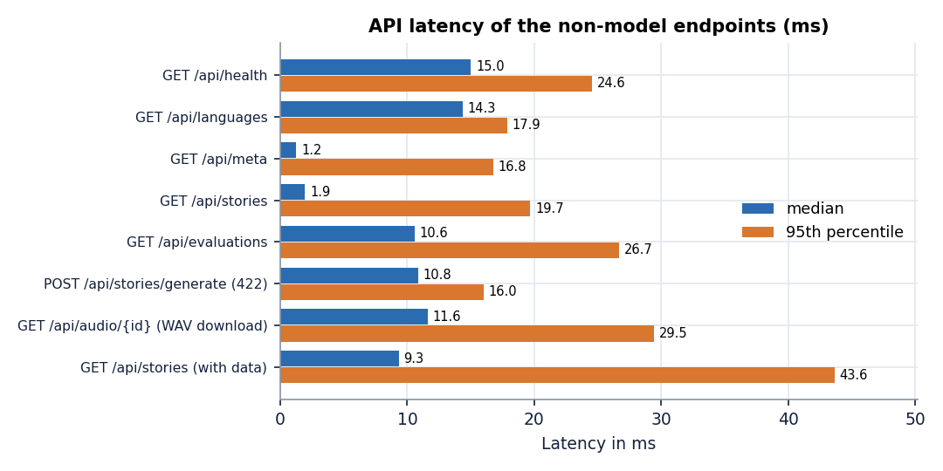
Figure 17: Median and 95th-percentile latency of the endpoints that do not run a model (127.0.0.1).
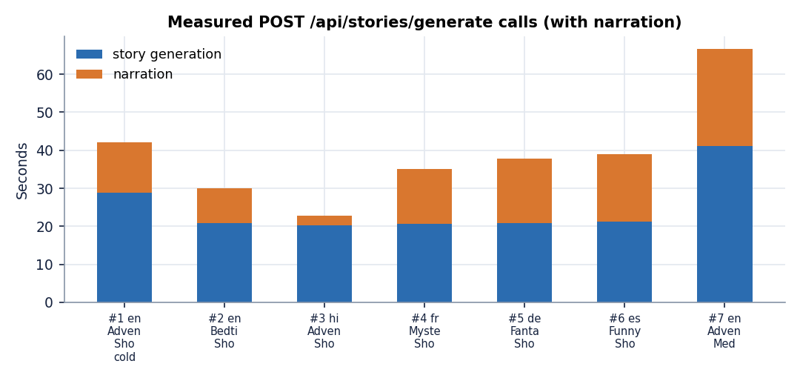
Figure 18: The seven measured generate-with-narration calls: story generation and narration time.

2.3 Security and error handling
StoryVox is a local single-user application and its security model is correspondingly simple. We list what exists and what does not, so that nobody assumes more.
• No authentication or accounts. Anyone who can reach the port can use the tool and read every story. The server is started on 127.0.0.1, which is the protection; the Docker command in the guide publishes the port only to 127.0.0.1 as well.
• Same origin. The browser reaches the API through the Vite proxy in development and through the same process in production, so the application defines no CORS rules and a page from another origin cannot read its responses.
• Input validation. The idea must be non-empty and at most 2,000 characters; the language, style and length must be among the offered values; the evaluation sample count must be 1 to 30 and the story list limit 1 to 200. Invalid values answer 422 with a sentence. Database access goes through the ORM, so values are parameterised.
• Audio paths. The path stored with each audio row is generated by the server (a unique file name with a time stamp and a random token inside the audio folder), and the client never supplies a path. The delete route removes a file only if the audio folder is among its parents. A helper ensure_within_directory that rejects paths outside the folder exists and is unit-tested, but no route calls it; the stream route resolves the stored path without that check, and its except ValueError branch can therefore never run. Because the paths come from the server's own database, we found no way for a request to exploit this, but the check should be wired in.
• Secrets. The application needs no API key. .env holds ports, model names and limits, is git-ignored, and the repository ships only .env.example. The only network access is the model download from the Hugging Face hub; trust_remote_code=True lets code from the model repository run at load time.
• Cross-site scripting. The front end renders story text as React text and uses no raw HTML insertion.
• Failure behaviour. A failed story model falls back to the composer; a failed narration leaves the story saved without audio; a failed recogniser leaves WER and CER empty with the error stored in the row; unexpected exceptions answer 500 with a generic sentence and are logged with a stack trace on the server.
• Concurrency and limits. Model loading is serialised by locks; every request uses its own database session; no rate limit, request-size limit beyond the idea length, HTTPS or queue exists, and no concurrent-load test was done.
The automated tests cover the validation messages, the 404 cases, the delete cascade, the streamed WAV and the directory helper (Chapter 7). They replace the models with stubs, so model failures are covered only by the experiment runs.

2.4 Installation and execution
The project guide asks for Python 3.11 or newer, Node.js 20 or newer, 8 GB of free disk space for the models and 8 GB of memory, and internet access on the first run. requirements.txt lists fastapi, uvicorn, sqlalchemy, pydantic, pydantic-settings, python-multipart, numpy, soundfile, jiwer, nltk, rouge-score, torch, transformers, accelerate, sentencepiece, tokenizers, datasets, librosa, pyttsx3, sentence-transformers, reportlab, pytest and httpx without version pins. The measurements in this report used Python 3.11.9, PyTorch 2.14.1, Transformers 5.20.2, FastAPI 0.143.3 and NumPy 1.26.4.
1. Open the project folder 8.ProjectCode and (optionally) copy .env.example to .env; ports 8402 and 5402 are preset.
2. Double-click run.bat. It rebuilds a .venv copied from another computer, installs requirements.txt and, if needed, npm install in frontend/, starts the API with uvicorn and the web application with Vite in two windows and opens http://localhost:5402. The first run downloads the models and can take 10 to 30 minutes or more.
3. Open Studio, type an idea, choose language, style and length, press Generate story, then play or download the narration. History lists past stories and Evaluation runs the measurement loop.
4. Run python -m pytest tests -q for the automated tests (29 passed in 5.8 s here). scripts/smoke_test.py walks the main flow through a running server; it was not run during this documentation work.
5. To use Docker, build the image and run it with the port published to 127.0.0.1:8402; the image contains the built web application, ffmpeg and espeak-ng. The Docker route was not tested; note that its start command binds 127.0.0.1 inside the container, which may stop a published port from reaching it.
Three practical notes come from this project's own run. `run.bat` was not used: the .venv in the folder pointed at a Python 3.14 that is not installed and the drive had too little free space to rebuild it, so the service was started with python -m uvicorn app.main:app --host 127.0.0.1 --port 8402 from the system Python and the built web application was served by the same process. `ffmpeg` must be on the PATH for the evaluation, because Whisper reads the WAV file through it; it is not in requirements.txt (the Dockerfile installs it). `pip install uroman` is needed for Korean. To reproduce the numbers of this report run, from 8.ProjectCode: python scripts/run_experiments.py all (then cjk), python scripts/measure_api.py against a running server, python scripts/run_story_asr.py, python scripts/run_tests.py and python scripts/make_report_facts.py. Appendix B repeats the instructions as a user guide with the screens.

3. KEY CODE WALK-THROUGHS

3.1 Prompt and title parsing (`story_generator.py`)
The whole control surface of the story is one instruction sentence: style, language name, length and the idea are put into a single string, and the model is asked to start with Title: . The instruction is sent as plain text, not through the model's chat template, which is the likely reason for the instruction echo seen in Chapter 8. _parse_model_output then looks for a bare Title: line; if there is none it tries the first short line, otherwise the title stays Untitled Story. A title written as **Title: ...** matches neither rule.
def build_prompt(prompt: str, language_name: str, style: str, length_option: str) -> str:
guidance = STYLE_GUIDANCE.get(style, STYLE_GUIDANCE["Custom"])
return (
f"Write an original {style.lower()} story in {language_name}, {guidance}. "
f"Target length: {length_option.lower()} (about {target_paragraphs(length_option)} short paragraphs). "
f"Start the first line with 'Title: ' followed by a short evocative title, then a blank line, "
f"then the story body only. Story idea: {prompt.strip()}"
)

def _parse_model_output(raw: str) -> tuple[str, str]:
text = (raw or "").strip()
title = "Untitled Story"
body = text
match = re.search(r"(?im)^\s*title\s*:\s*(.+?)\s*$", text)
if match:
title = match.group(1).strip()[:150] or title
body = text[match.end():].strip() or text
else:
first_line = text.splitlines()[0].strip() if text else ""
if 0 < len(first_line) < 120 and len(text.splitlines()) > 1:
title = first_line.strip("#* ").strip()[:150]
body = "\n".join(text.splitlines()[1:]).strip() or text
body = re.sub(r"\n{3,}", "\n\n", body).strip()
return title, body

3.2 Story generation with a fallback (`story_generator.py`)
The model is sampled with temperature 0.8 and top-p 0.9 and a token budget that depends on the length option. If the model fails to load, raises, or returns fewer than 20 words, the composer writes the story instead, and the model identifier stored with the story says which path was taken. The language check that Chapter 8 shows to be missing would belong in this block, between parsing and returning.
generator = _try_load_pipeline(model_id)
if generator is not None:
try:
outputs = generator(
full_prompt,
max_new_tokens=max_tokens_for_length(length_option),
temperature=settings.story_temperature,
top_p=settings.story_top_p,
do_sample=True,
return_full_text=False,
)
raw = outputs[0].get("generated_text", "") if outputs else ""
title, body = _parse_model_output(raw)
if len(body.split()) < 20:
raise RuntimeError("Model returned too little text; using local composer.")
return title, body, model_id, round(time.perf_counter() - started, 3)
except Exception as exc:
logger.warning("StoryVox: story model inference failed (%s). Using local composer.", exc)
title, body = local_fallback_story(prompt, language_code, language["name"], style, length_option)
return title, body, "storyvox-local-fallback-v1", round(time.perf_counter() - started, 3)

3.3 Chunked narration (`tts_service.py`)
The speech model is called on one chunk at a time (at most 380 characters, cut at sentence ends and at the Hindi danda), each waveform is normalised to a peak of 0.9, the chunks are joined with a quarter-second pause, and silence is rejected. The checkpoint comes from the language table, which is why a missing checkpoint (Italian, Chinese, Japanese) fails here and not earlier.
def synthesize(self, text: str, language_code: str) -> tuple[np.ndarray, int, str]:
lang = LANGUAGE_MAP.get(language_code)
if lang is None:
raise ValueError("This language is not currently supported for narration.")
checkpoint = lang["tts_checkpoint"]
tokenizer, model = self._load(checkpoint)
import torch

device = next(model.parameters()).device
segments: list[np.ndarray] = []
for chunk in chunk_text(text, max_chars=380):
inputs = tokenizer(chunk, return_tensors="pt")
inputs = {k: (v.to(device) if hasattr(v, "to") else v) for k, v in inputs.items()}
with torch.no_grad():
out = model(**inputs).waveform
wav = out.squeeze().detach().float().cpu().numpy().astype(np.float32)
if wav.size:
peak = float(np.max(np.abs(wav)))
if peak > 0:
wav = (wav / max(peak, 1e-6) * 0.9).astype(np.float32)
segments.append(wav)
if not segments:
raise RuntimeError("Narration could not be generated. Check the server log for details.")
audio = concat_wav_segments(segments, sample_rate=TARGET_SR)
if audio.size == 0 or is_silent(audio):
raise RuntimeError("Narration could not be generated. Check the server log for details.")
# MMS checkpoints natively emit 16 kHz; keep TARGET_SR for consistency.
return audio.astype(np.float32), TARGET_SR, checkpoint

3.4 Provider chain (`tts_service.py`)
synthesize_story_narration tries the MMS provider and then the operating-system provider. A ValueError stops the chain (bad input); any other error is logged and the next provider is tried. This is how Italian ends up with an English voice: the first provider fails on the missing checkpoint and the second one speaks any text it is given.
for provider in (MMSTTSProvider(), SystemTTSProvider()):
try:
audio, sample_rate, model_id = provider.synthesize(story_text, language_code)
break
except ValueError:
raise
except Exception as exc:
last_error = exc
logger.warning("StoryVox: TTS provider %s failed: %s", provider.name, exc)
continue

3.5 Where the evaluation breaks (`evaluation_service.py`)
After narration the evaluation transcribes the WAV file and compares the transcript with the story text. The call has no chunking option; for audio over 30 seconds transformers 5.20.2 raises an error, the except branch stores it as asr_error, and WER and CER stay empty. The stand-alone script scripts/run_story_asr.py differs in one argument, chunk_length_s=30, and produces the numbers in Chapter 8.
# Transcribe for intelligibility
try:
from app.services.asr_service import transcribe_wav
from app.services.tts_service import resolve_audio_abs_path

hyp = transcribe_wav(resolve_audio_abs_path(rel), item["language_code"])
row["asr_transcription"] = hyp[:500]
w = wer(body, hyp)
c = cer(body, hyp)
row["wer"] = w
row["cer"] = c
wers.append(w)
cers.append(c)
except Exception as exc:
row["asr_error"] = str(exc)[:300]

3.6 Safe audio path (`utils/__init__.py`)
Audio is served by database id. Before any stored path is used it is resolved and must lie inside the audio folder; the same check guards deletion.
def ensure_within_directory(base: Path, target: Path) -> Path:
resolved_base = base.resolve()
resolved_target = target.resolve()
if resolved_base not in resolved_target.parents and resolved_target != resolved_base:
raise ValueError("Audio path escapes the StoryVox audio directory.")
return resolved_target

4. IMPLEMENTATION DECISIONS AND THEIR REASONS
The main implementation decisions, the reason for each and what the measurements later showed are listed in the table below.
Table 8: Implementation decisions and their reasons
Decision | Reason | What the measurements showed
Use pretrained models, train nothing | A student project on a laptop cannot train a story model or a multilingual speech model | Narration is good (mean CER 0.088); the story model ignores the language request
Qwen3-0.6B as story model | Small enough for CPU and memory; open weights; multilingual | About 9 tokens per second; short, repetitive stories; mostly English
MMS-TTS (VITS) per language | One checkpoint per language, 16 kHz, runs at about a quarter of real time on a CPU | RTF 0.22 to 0.23 for 11 of 12 languages; three advertised checkpoints do not exist
TTSProvider abstraction with an OS fallback | A story should always be speakable and models can be swapped | Fallback gives an English voice for Italian and almost nothing for Chinese or Japanese
Prompt as plain text | Simplest call to the text-generation pipeline | Instruction echo 0.097 against 0.006 with the chat template
Offline composer | The application must answer even without the model | Instant but template text; high similarity only because it quotes the idea
Chunks of at most 380 characters | Keep each speech-model call short and the memory flat | Chunking tests pass; no audible seams were rated
Whisper-small for evaluation | Multilingual and small enough for CPU | Fails on audio over 30 s without chunking; its own error is inside every WER
SQLite and local WAV files | No server to install, everything stays on the machine | Library of seven stories lists in about 2 to 9 ms; foreign keys not enforced by the engine
FastAPI plus React | Typed validation, automatic docs, a modern interface over the same service | 11 routes, 5 pages, light calls in 1 to 15 ms
Fixed lengths by token budget (220/420/700) | Predictable time | Words came out 175, 316 and 418, because the model stops early

Three decisions deserve a longer note. The first is to train nothing. It makes the project reproducible on any laptop, and it means every quality problem in Chapter 8 belongs to a model chosen off the shelf, not to a training mistake; the cost is that the only levers left are the prompt, the sampling settings, the model choice and the glue code. The second is the fallback design. Falling back silently keeps the interface working, but it also produced the three most misleading screens of the project (an English voice for Italian, a composer story presented like a model story, an empty narration for Japanese); a future version should say on screen which path was used. The third is the plain-text prompt: it was the quickest way to call the pipeline, and the experiments suggest it is also the weakest.

